Ohio Hospital Project Cost Tracking Report
Report Date: October 25, 2025

1. Project Summary
Task ID | 100 | 200 | 300 | 400 | 500 | 600 | 700
Task Name | Design | Mob | Drilling | Construction | Heating | Demob | Reporting | Total
Status | Completed | Completed | Completed | In Progress | Future | Future | Future | N/A
Schedule | 04/01/25 - 05/30/25 | 06/01/25 - 08/22/25 | 07/21/25 - 09/01/25 | 09/02/25 - 10/31/25 | 11/03/25 - 05/21/26 | 05/22/26 - 06/12/26 | 05/22/26 - 07/16/26 | 04/01/25 - 07/16/26
Planned Duration | 48 | 50 | 35 | 30 | 200 | 16 | 40 | 471
Actual Duration | 44 | 60 | 31 | 39 | N/A | N/A | N/A | 207
Duration % | 92% | 120% | 89% | 130% | N/A | N/A | N/A | 44%
Invoice | $105,054 | $344,279 | $592,513 | $279,193 | $648,306 | $278,872 | $46,150 | $2,294,368
Income Received | $105,054 | $284,997 | $272,151 | $0 | $0 | $0 | $0 | $662,202
Income % | 100% | 83% | 46% | N/A | N/A | N/A | N/A | 29%
Planned Spend | $77,818 | $357,757 | $498,552 | $218,009 | $437,461 | $189,445 | $34,185 | $1,813,227
Actual Spend | $17,797 | $224,822 | $409,785 | $170,741 | $0 | $0 | $0 | $823,145
Spent Cost % | 23% | 63% | 82% | 78% | N/A | N/A | N/A | 45%
Profit % | 490% | 27% | -34% | -100% | N/A | N/A | N/A | -20%
Planned Labor Days | 138 | 20 | 91 | 195 | 537 | 114 | 66 | 1161
Actual Labor Days | 31 | 14 | 132 | 163 | 0 | 0 | 0 | 340
Applied Labor % | 23% | 70% | 145% | 84% | N/A | N/A | N/A | 29%

This section provides a comprehensive overview of the Ohio Hospital Project's current status, including financial performance, schedule progress, and resource utilization. The summary table above presents key metrics for each project phase, allowing for quick assessment of project health and identification of areas requiring attention.
Completed Tasks Analysis:
• Design and Plans For Thermal Remediation: Completed on schedule (92% of planned duration). Full income received (100%). Cost within budget (23% of planned). Profitable (490% margin). Labor efficient (23% of planned).
• Site Preparation & Mobilization Prep: Completed behind schedule (120% of planned duration). Partial income received (83%). Cost within budget (63% of planned). Profitable (27% margin). Labor efficient (70% of planned).
• Drilling and Well Installation: Completed on schedule (89% of planned duration). Partial income received (46%). Cost within budget (82% of planned). Loss (-34% margin). Note: This negative margin may be due to the lagging of receiving invoices, which are usually sent at the end of task or end of month. Labor over budget (145% of planned).
In Progress Task:
• Construction and Installation: Currently active with ongoing operations. Currently burning 78% of the budget and 84% of the planned labor while the duration is at 130% expected. A delay is expected.
Future Tasks (3 remaining):
• Operation and Maintenance: Actual: 11/03/25 - 05/21/26 | Baseline: 10/14/2025 - 05/01/2026
• Demobilization: Actual: 05/22/26 - 06/12/26 | Baseline: 05/04/2026 - 05/25/2026
• Reporting: Actual: 05/22/26 - 07/16/26 | Baseline: 05/04/2026 - 06/26/2026
Important Notes:
• QuickBook account entries may have reporting lag, affecting current and recently completed task financial percentages.
• Invoices are typically sent to clients at project completion, which may cause temporary discrepancies in income tracking.
• Existing equipment costs are not reflected in QuickBook data and will be added once inventory reports are received.
Percentage Formulas:
• Duration % = (Actual Duration / Planned Duration) × 100
• Income % = (Income Received / Invoice Amount) × 100
• Spent Cost % = (Actual Spend / Planned Spend) × 100
• Profit % = ((Income Received / Actual Spend) - 1) × 100
• Applied Labor % = (Actual Labor Days / Planned Labor Days) × 100

2. Invoice Tracking
This section focuses on the project's invoicing and income receipt performance. Invoice tracking is critical for cash flow management and project profitability assessment.
Key aspects covered:
• Planned vs actual invoice amounts by project phase
• Income receipt tracking and collection efficiency
• Invoice-to-income conversion rates
• Cash flow analysis and payment timing
The invoice tracking data helps identify potential billing delays, collection issues, or scope changes that may impact project cash flow and profitability.
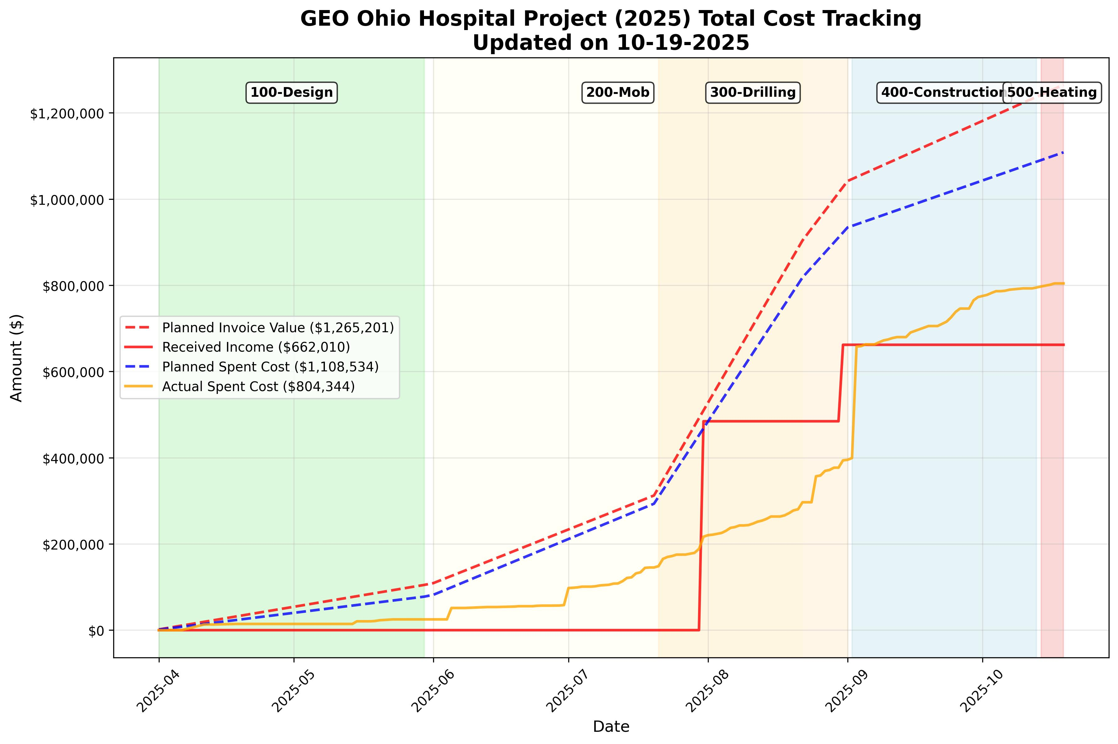
Figure 1: Total Cost Tracking Overview showing invoice and income trends

3. Cost Analysis
This section provides detailed cost analysis across five key categories: Labor, Parts, Travel, Outsource, and Equipment. Each subsection includes planned vs actual cost tracking with task-based shading to identify cost patterns by project phase.
The cost analysis helps identify:
• Budget performance by category
• Cost overruns or savings opportunities
• Resource allocation efficiency
• Category-specific trends and patterns

3.1 Labor Costs
Labor costs represent the largest component of project expenses and include both on-site and remote personnel costs. This analysis tracks planned vs actual labor expenditures across all project phases.
QuickBook Accounts Used: No specific labor accounts (5101/5102) found in current data. Labor costs are calculated separately from labor hours data.
Key metrics:
• Total labor cost performance
• On-site vs remote labor cost distribution
• Labor cost trends by project phase
• Efficiency indicators and cost per labor day
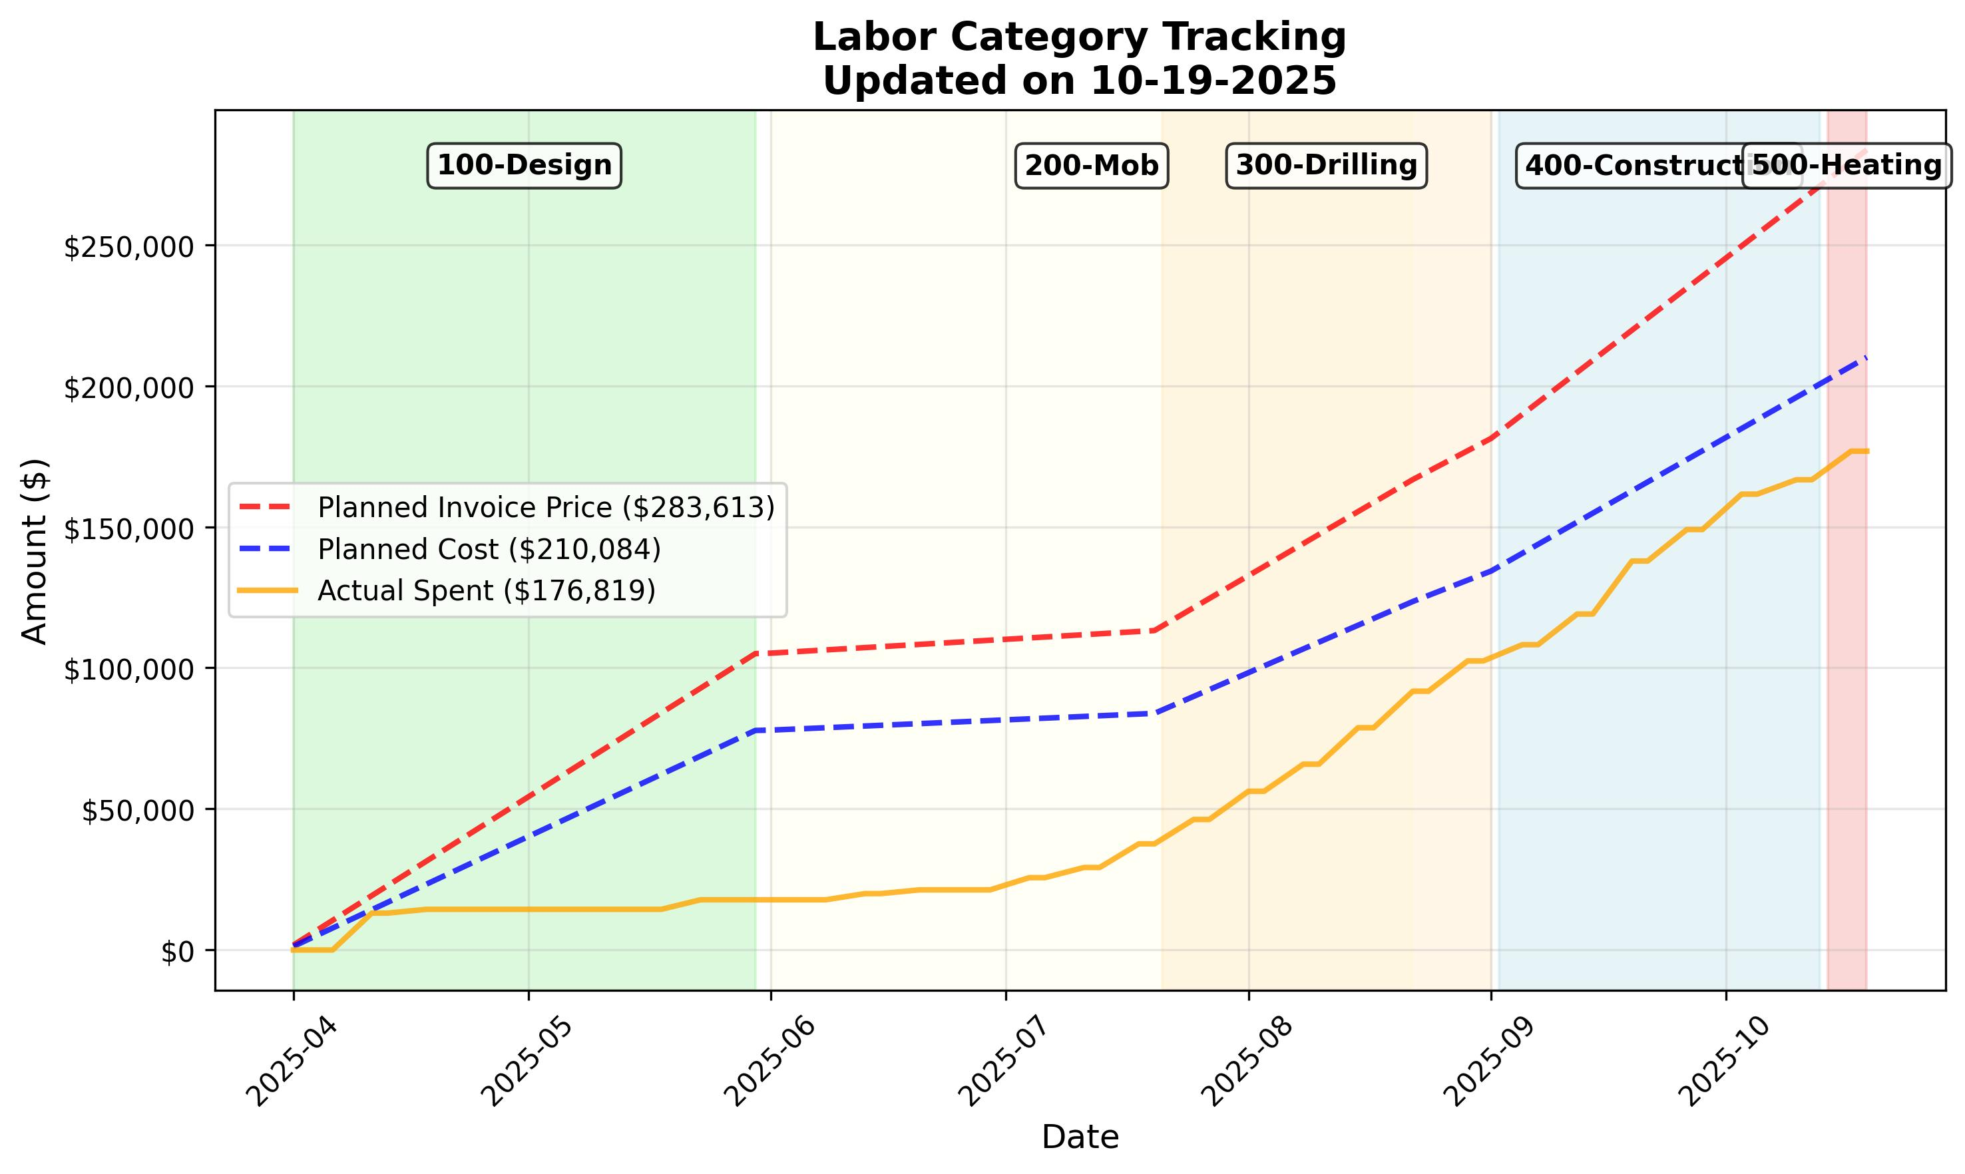
Figure 2: Labor Cost Tracking

3.2 Parts and Materials Costs
Parts and materials costs include all direct materials required for project execution, from basic supplies to specialized equipment components.
QuickBook Accounts Used: 5004 - GTR Cost of Sales - Parts, 5111 - Parts & material costs (Direct), 5128 - Health & Safety Equip (Direct)
Analysis includes:
• Material cost tracking and variance analysis
• Procurement efficiency and timing
• Material cost trends by project phase
• Inventory management and waste reduction opportunities
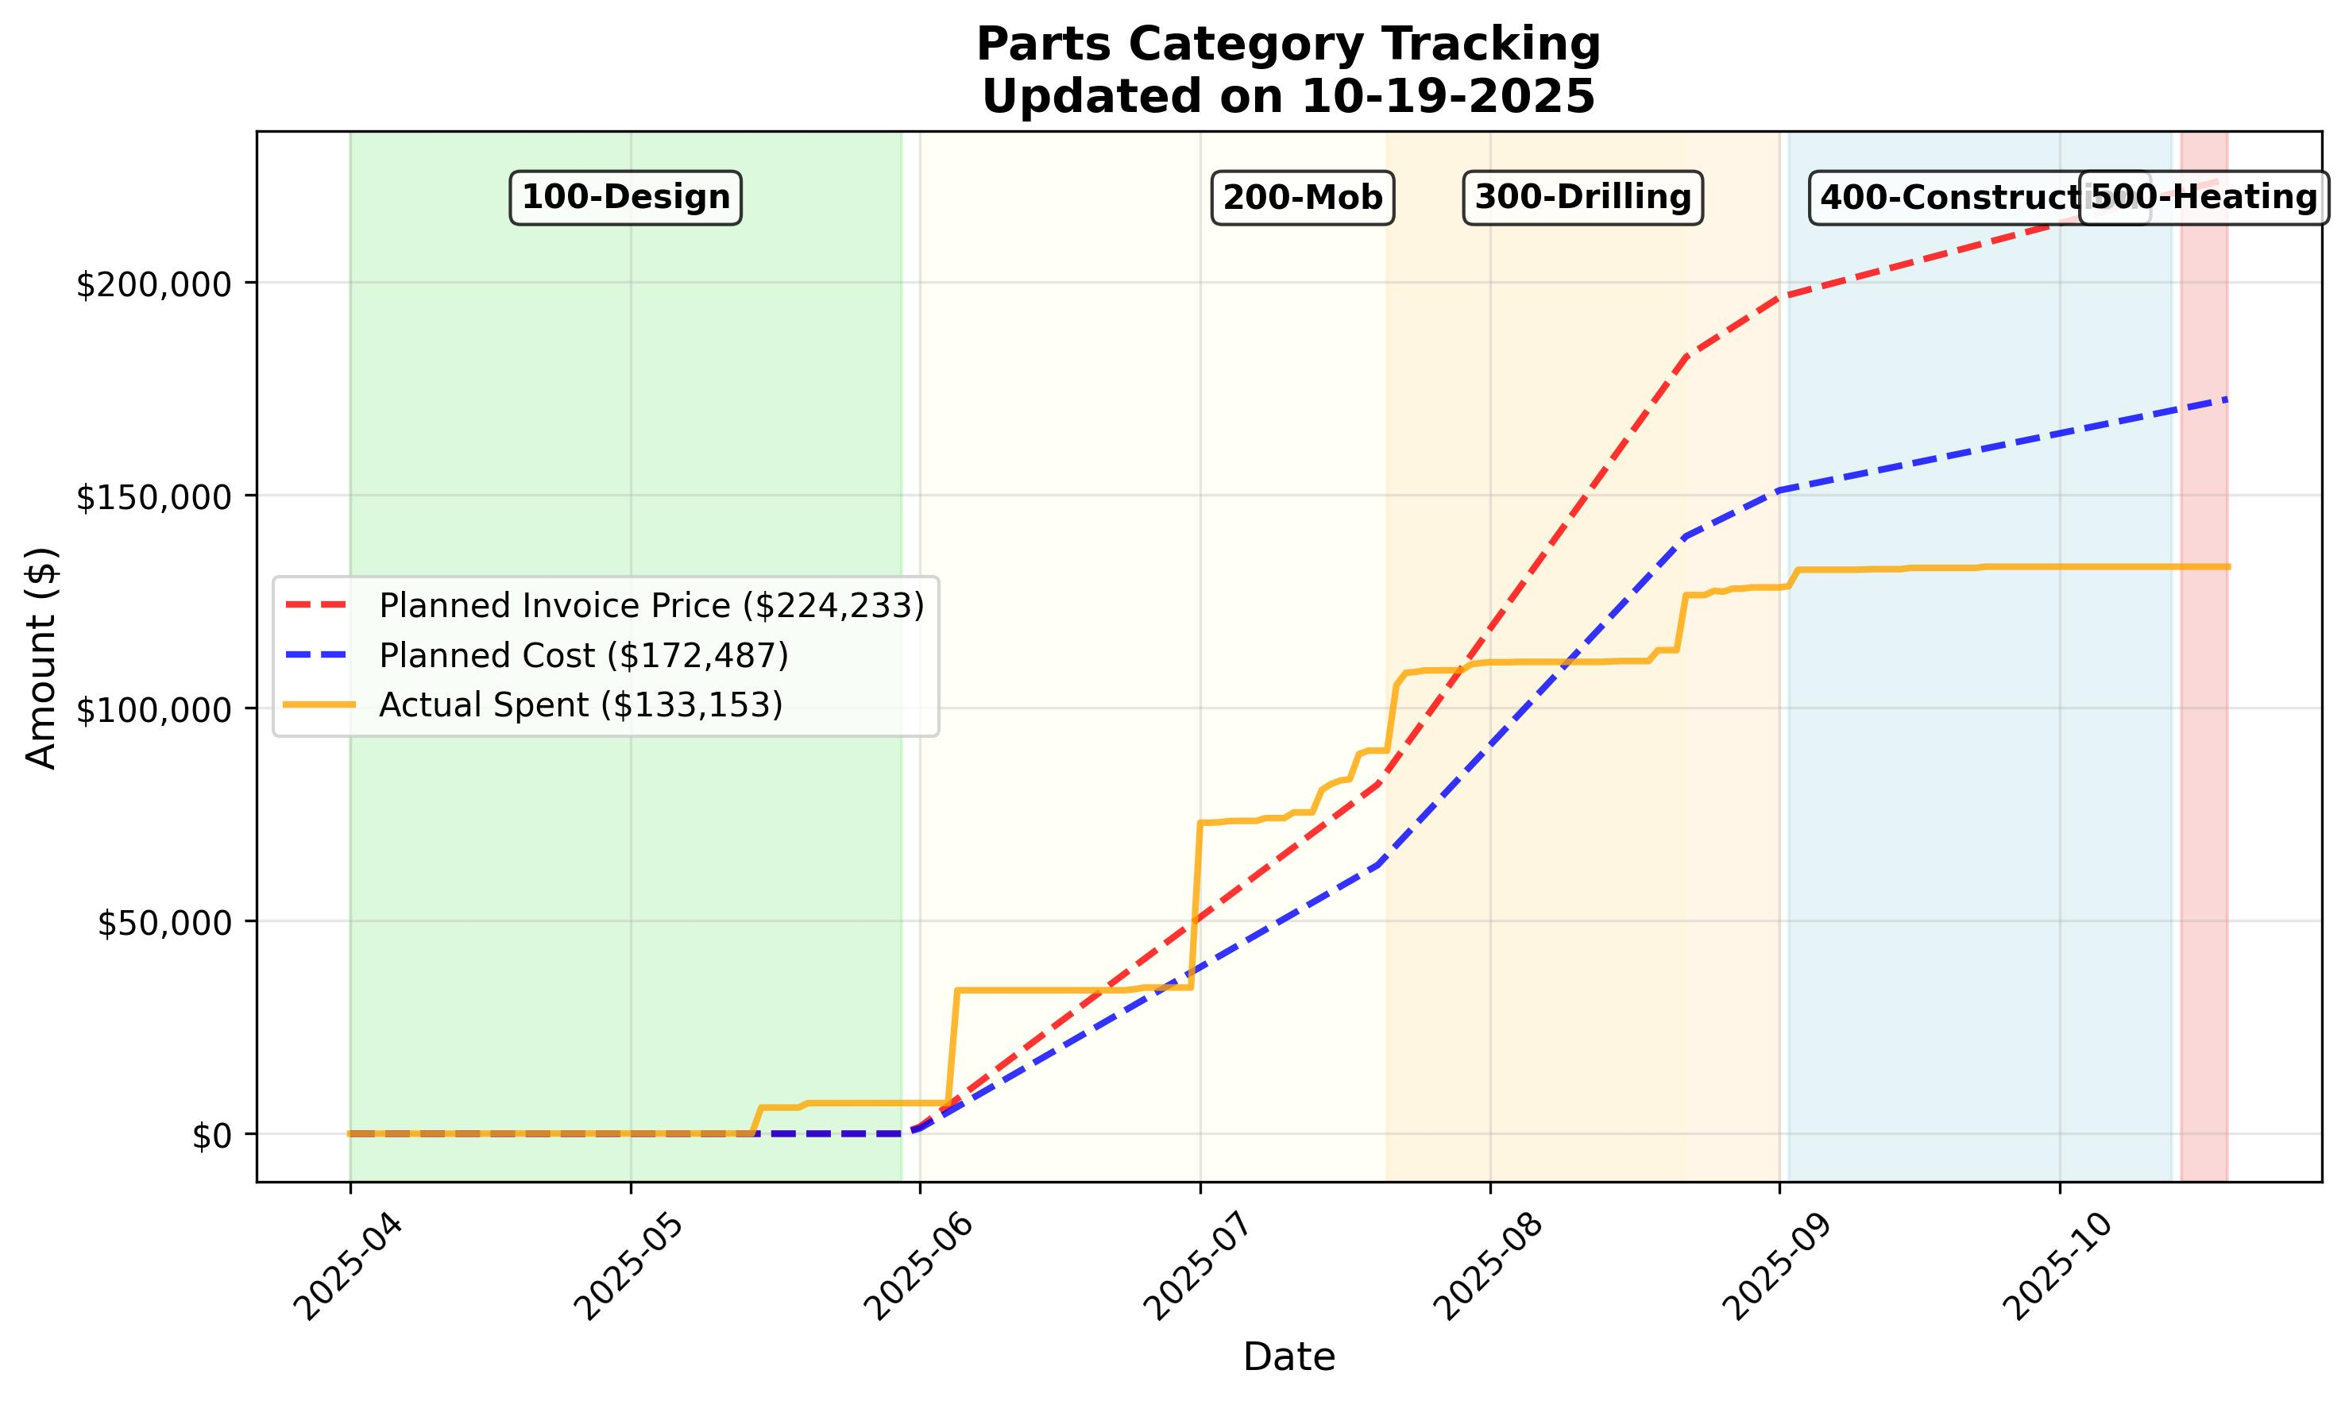
Figure 3: Parts and Materials Cost Tracking

3.3 Travel and Per Diem Costs
Travel and per diem costs cover all transportation, accommodation, and meal expenses for project personnel, including both planned site visits and emergency travel requirements.
QuickBook Accounts Used: 5105 - Travel - Airfare (Direct), 5106 - Travel - Hotel (Direct), 5107 - Travel - Other (Direct), 5107.1 - Travel - Car Rental, 5108 - Meals & entertainment (Direct), 5122 - Motor vehicle exp (Direct), 5123 - Auto fuel (Direct)
Key considerations:
• Travel cost efficiency and optimization
• Per diem rate compliance and trends
• Travel cost distribution by project phase
• Remote work impact on travel expenses
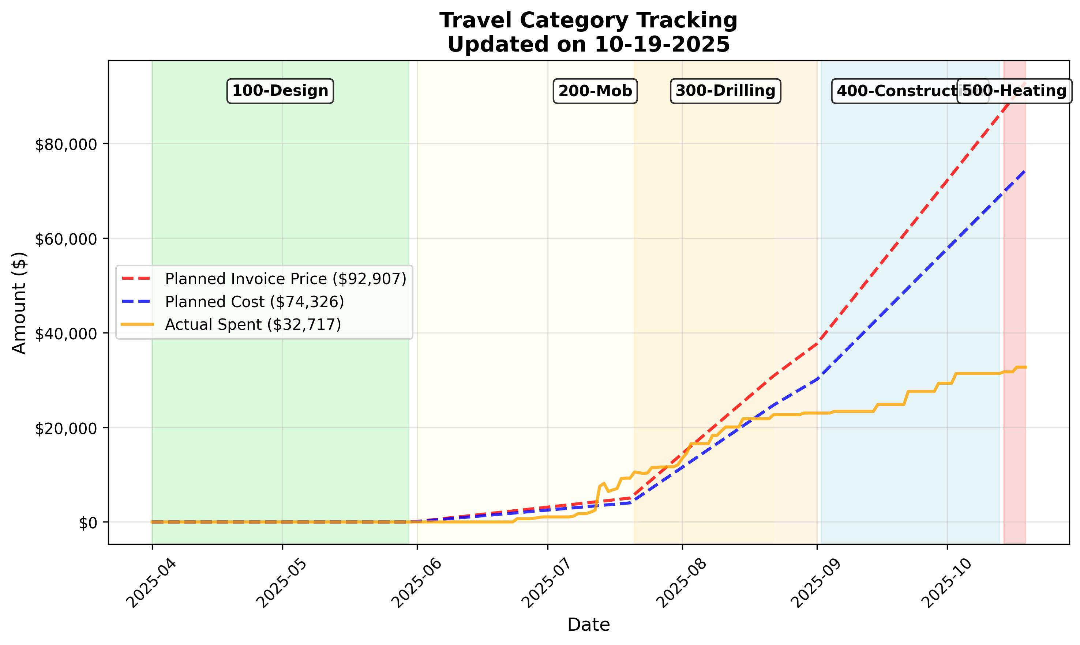
Figure 4: Travel and Per Diem Cost Tracking

3.4 Outsource Costs
Outsource costs include all third-party services, subcontractors, and external consultants required for project execution.
QuickBook Accounts Used: 5006 - Drilling Expense, 5113 - Repairs & maint (Direct), 5115 - Rent - Equipment (direct), 5120 - Outside services (Direct), 5121 - Freight & Shipping (Direct), 5129 - Misc expenses (Direct)
Analysis covers:
• Subcontractor cost performance and management
• Service provider efficiency and quality
• Outsource cost trends and vendor performance
• Risk management and cost control measures
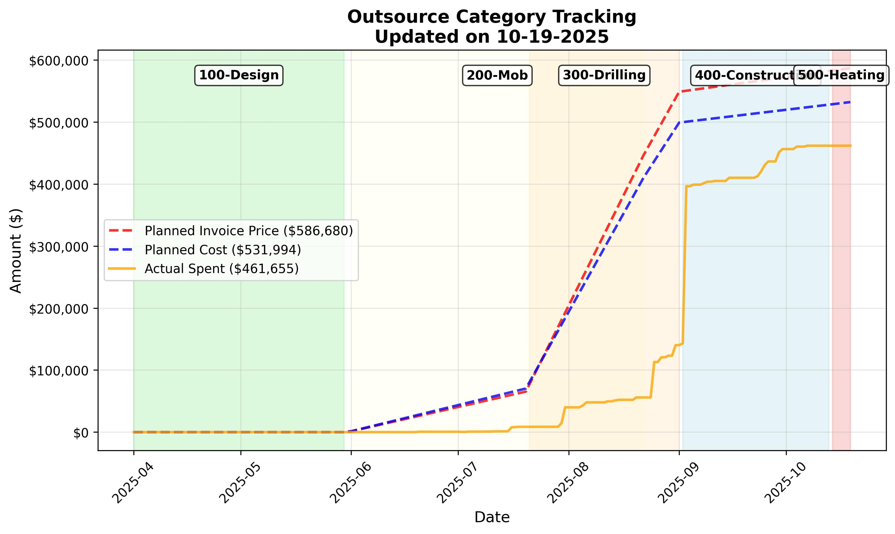
Figure 5: Outsource Cost Tracking

3.5 Equipment Costs
Equipment costs encompass all machinery, tools, and specialized equipment required for project execution, including purchase, rental, and maintenance expenses.
QuickBook Accounts Used: No specific equipment accounts (18xx or 5113) found in current data.
Important Note:
The existing equipment costs do not reflect in the QuickBook data associated with this project, therefore they are not added here yet. Once the inventory cost for those equipment is added, the total cost for Task 200 (Site Preparation & Mobilization Prep) will expect to increase as well.
Key factors:
• Equipment utilization efficiency and cost per hour
• Purchase vs rental cost analysis
• Equipment maintenance and repair costs
• Equipment cost trends and lifecycle management
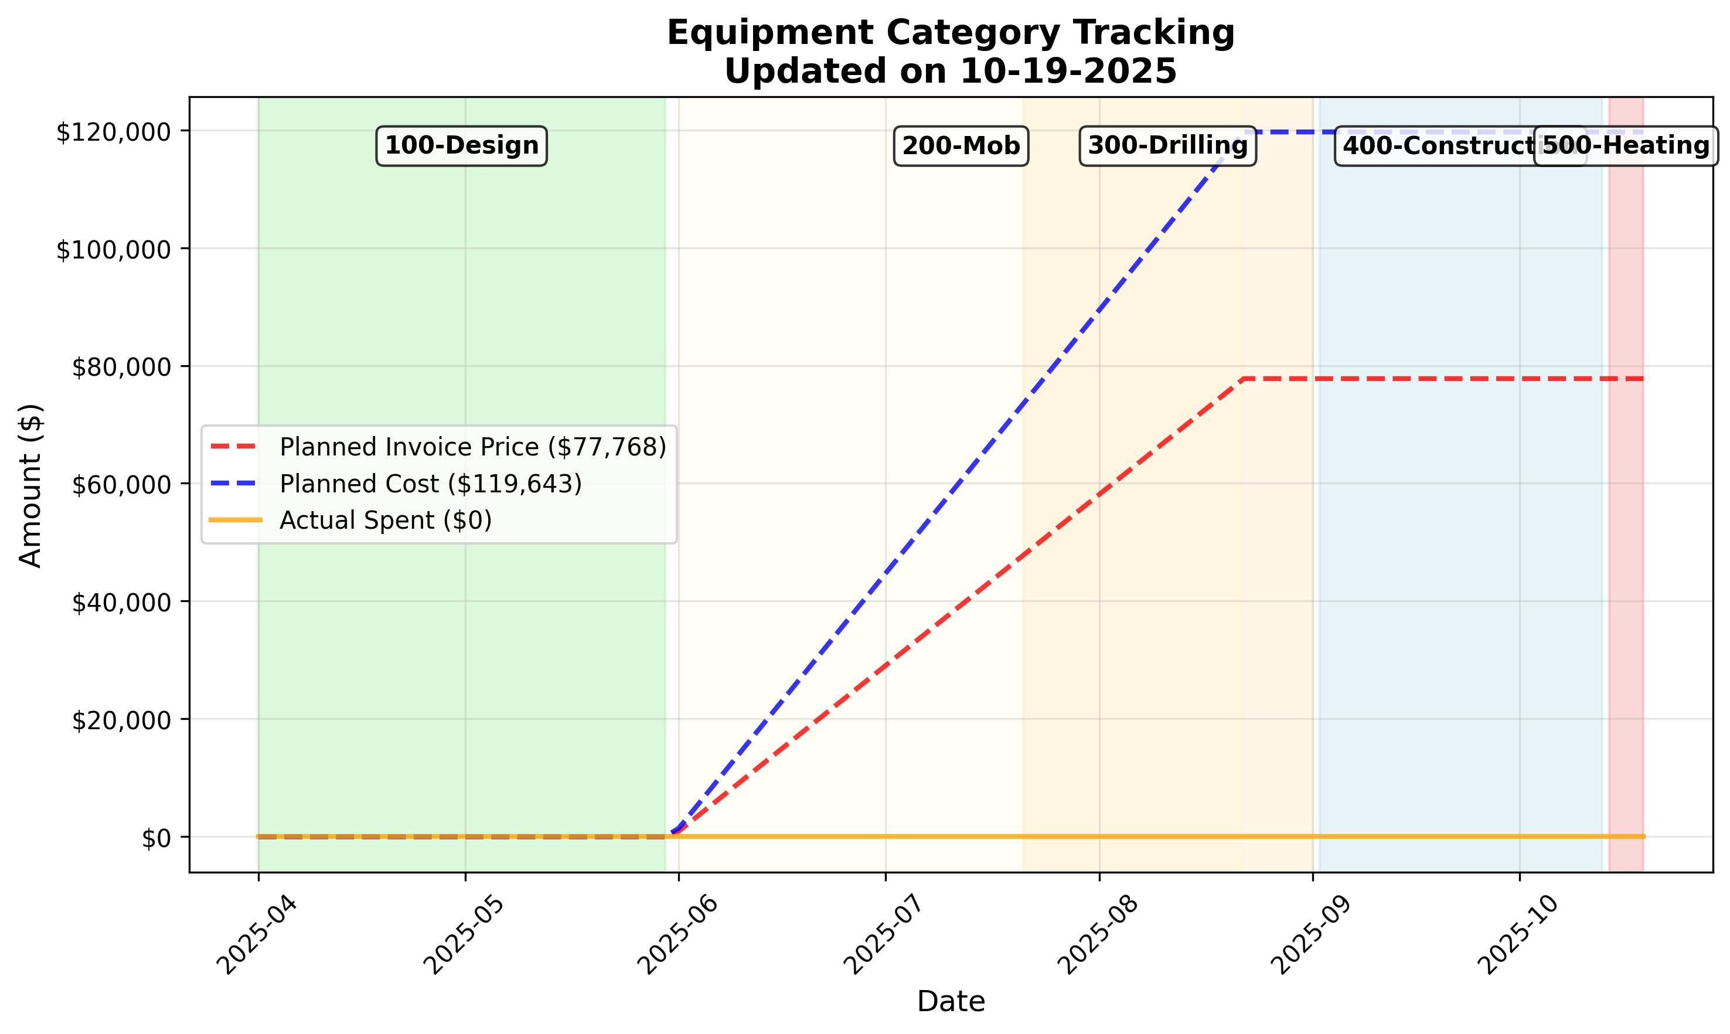
Figure 6: Equipment Cost Tracking

4. Labor Analysis
This section provides detailed analysis of labor utilization across the project, comparing planned vs actual labor days for both on-site and remote personnel. The analysis helps identify labor efficiency, resource allocation patterns, and potential optimization opportunities.
Key metrics analyzed:
• On-site labor day utilization and efficiency
• Remote labor day tracking and productivity
• Labor distribution across project phases
• Resource planning accuracy and variance analysis

4.1 On-Site Labor Analysis
On-site labor represents personnel physically present at the project location, including field technicians, supervisors, and specialized workers. This analysis tracks planned vs actual on-site labor days by month, providing insights into field productivity and resource utilization.
Key insights:
• Monthly on-site labor utilization patterns
• Seasonal variations and project phase impacts
• Labor efficiency indicators and productivity trends
• Resource allocation optimization opportunities
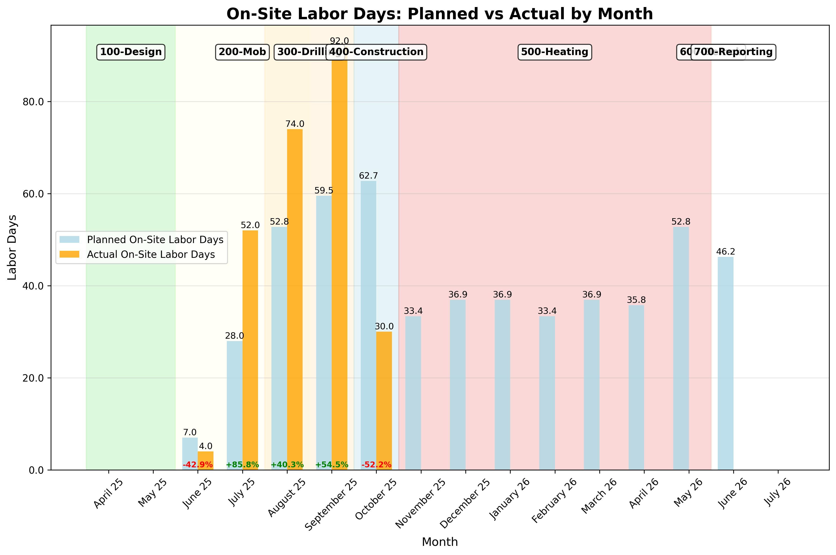
Figure 7: On-Site Labor Days Comparison

4.2 Remote Labor Analysis
Remote labor includes personnel working off-site, including engineers, project managers, and support staff. This analysis tracks planned vs actual remote labor days, providing insights into remote work efficiency and resource planning accuracy.
Analysis includes:
• Remote labor utilization and productivity metrics
• Work-from-home efficiency and cost benefits
• Remote labor distribution across project phases
• Technology and communication impact on remote productivity
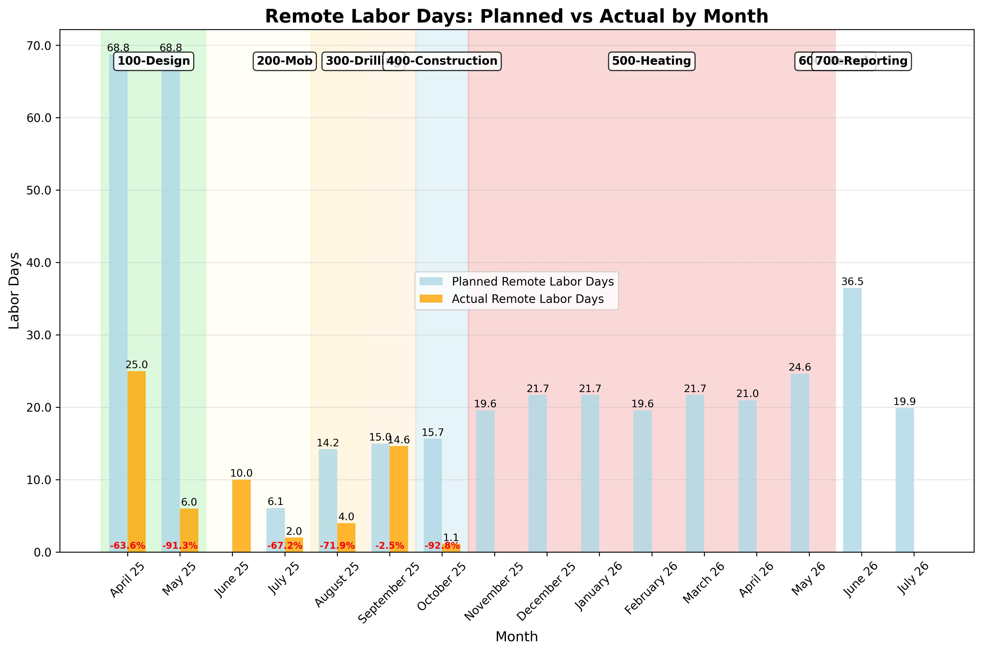
Figure 8: Remote Labor Days Comparison

